Water Efficiency Case Study: Swansea Guildhall
WE0019/D6/LBC005 – Water Efficiency Audit & Water Efficient Product Installation

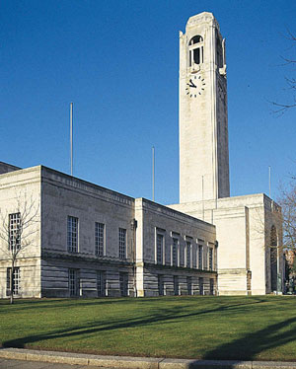

At a glance:
- Shows the impact of simple but effective water efficiency measures
- Water use reduced by over 20%
- Savings on water alone expected to be 1,500 m3/year (£1,800/year based on £1.22/m3).

As part of DCWW’s (Dwr Cymru Welsh Water) water efficiency program, Swansea Council was offered assistance in reducing their water consumption in their council buildings.
The Guildhall is one of the main office buildings of the City and County of Swansea Council, designed by Percy Thomas and opened in 1934.
A Water Efficiency audit was carried out and a number of basic water efficiency measures were installed in order to reduce consumption.
The cost of the audit and products (supply and fit) were funded in total by DCWW, and evidence of savings was used to contribute towards regulatory targets for DCWW and water cost and CO2 reduction targets for Swansea Council.
